BUZON ADJUSTABLE PEDESTALS

SECTION 07 76 00 - ROOF PAVERS

- GENERAL

  - SUBMITTALS

    - Action Submittals:
      - Shop Drawings: Illustrate products, installation layouts, heights, and relationship to adjacent construction.
      - Product Data: Manufacturer’s descriptive data and product attributes.
      - Samples: [Selection samples.] [Verification samples.]

  - QUALITY ASSURANCE

    - Manufacturer Qualifications: Firm specializing in manufacture of paver pedestal systems, with minimum [15] [__] years’ experience.

    - Installer Qualifications: Firm specializing in work of this Section, with minimum [2] [__] years’ experience.

    - Mockup: Minimum [4 x 4’] [__ x __] feet. Approved mockup [may] [may not] remain as part of the Work.

  - WARRANTIES

    - Manufacturer’s 10 year warranty for pedestals and accessories against manufacturing defective.

- PRODUCTS

  - MANUFACTURERS

    - Pedestal system is based on products by Buzon Pedestals. http://www.buzonpedestals.com/
- US Contact: Buzon USA West
- Sales: 503-954-3336, sales@buzonusawest.com

    - Substitutions: [Refer to Division 01.] [Not permitted.]

  - MATERIALS

    - Precast Concrete Roof Pavers:
      - Source: [__________] by [_____________]] [or approved substitute]
      - Size: [24 x 24] [__ x __] inches x [2] [__] inches thick.
      - Color: [____.] [To be selected from manufacturer's full color range.]
      - Surface texture: [Sandblasted.] [____.]

**** OR ****

    - Wood Roof Pavers:
      - Source: [__________] by [__________] [or approved substitute].
      - Species: [Ipe.] [Cumaru.] [Massaranduba.] [Itauba.] [Black Locust] [Thermally_Modifed Ash] [____.]
      - Size: [24 x 24] [24 x 48] inches x [__] inches thick.
      - Color: [Natural.] [____.] [To be selected from manufacturer's full color range.]
      - Surface texture: [Smooth.] [Ribbed.] [____.]
      - Finish: [Natural, end cuts sealed.] [____.]
      - Fire rating: Class A, tested to ASTM E108. [Thermally-Modified Ash: Class B, WUI Certified.] [Non-FSC Certified.] [FSC Certified– 100 Percent.]

**** OR ****

    - Porcelain Roof Pavers:
      - Source: [____] by [__________] [or approved substitute].
      - Nominal Size: [24 x 24] [__ x __] inches x [__] inches thick.
      - Color: [____.] [To be selected from manufacturer's full color range.]
      - Surface texture: [R10 or R11 DCOF.] [____.]
      - Fire rating: Class A, tested to ASTM E108.

**** OR ****

    - Stone Roof Pavers, Stair Treads, Risers or Planks:
      - Type: [Granite. [Limestone.] [Basalt.] [Marble.] [Sandstone.] [Slate.] [____.]
      - Source: [__________] [or approved substitute].
      - Size: [24 x 24] [__ x __] inches x [__] inches thick.
      - Surface texture: [Honed.] [Polished.] [Flamed and Brushed.] [Flamed and Water-Jetted.] [Lychee.] [Pineapple.] [Mushroom.] [Adze.] [Scored and Chiseled.] [Antiqued.] [Sandblasted.] [Engraved.] [Sawn.] [____.]
      - Dimensional Tolerance: +/- 1mm LxW, +/- 2mm Thickness
      - Flexural strength: [__], tested to ASTM C880.
      - Modulus of rupture: [__], tested to ASTM C99.

  - ACCESSORIES

    - Paver Pedestals:
      - Product: Buzon BC-Series.
      - Description: 80 percent polypropylene and 20 percent talc content, ultraviolet stabilized, weather, sea salt, and chemical resistant.
      - Maximum load capacity: 2,200 lbs (997 kg) per pedestal (to failure); 1,000 lbs per pedestal after safety factor.
      - Self-Ignition Temperature: Provide plastic pedestal with self-ignition temperature greater than 650 degrees F (343 degrees C) in accordance with ASTM D1929 test method.
      - Recycled content: 80 percent.
      - Height: Adjustable from 1/8 inch to 44 inches.
      - Slope: Adjustable from 0 to 15 percent.
      - Provide spacers and correctors to achieve heights and dimensions indicated on Drawings.
      - Maintain pedestal bodies in vertical position (plumb) and heads level by means of bottom-mounted slope correctors.
      - Produce sloped walking surfaces and ramps by means of top-mounted slope correctors.

**** OR ****

    - Paver Pedestals:
      - Product: Buzon PB-Series.
      - Description: 80 percent polypropylene and 20 percent talc content, ultraviolet stabilized, weather, sea salt, and chemical resistant.
      - Maximum load capacity: 1,910 lbs (866 kg) per pedestal (to failure); 900 lbs per pedestal after safety factor.
      - Self-Ignition Temperature: Provide plastic pedestal with self-ignition temperature greater than 650 degrees F (343 degrees C) in accordance with ASTM D1929 test method.
      - Recycled content: 80 percent.
      - Height: Adjustable from 1/8 inch to 38 inches.
      - Slope: Adjustable from 0 to 15 percent.
      - Provide spacers and correctors to achieve heights and dimensions indicated on Drawings.
      - Maintain pedestal bodies in vertical position (plumb) and heads level by means of bottom-mounted slope correctors.

- EXECUTION

  - INSTALLATION

    - Install in accordance with manufacturer's instructions and approved Shop Drawings.
      - Substrate bearing surface on which pedestals are set (such as rigid insulation) shall provide equivalent or greater than 60 psi (414 kPa) compressive strength material when supporting pedestal-pavers or decking.

    - Support each paver per manufacturer’s recommendations.

    - Cut pavers to fit at perimeter and around penetrations without voids, or use pedestal-system perimeter spacer-tabs.

    - Allowable Tolerances:
      - Maximum variation from [level] [or] [indicated slopes] of paver surface: Plus or minus [1/4] [__] inch in 10 feet.

END OF SECTION

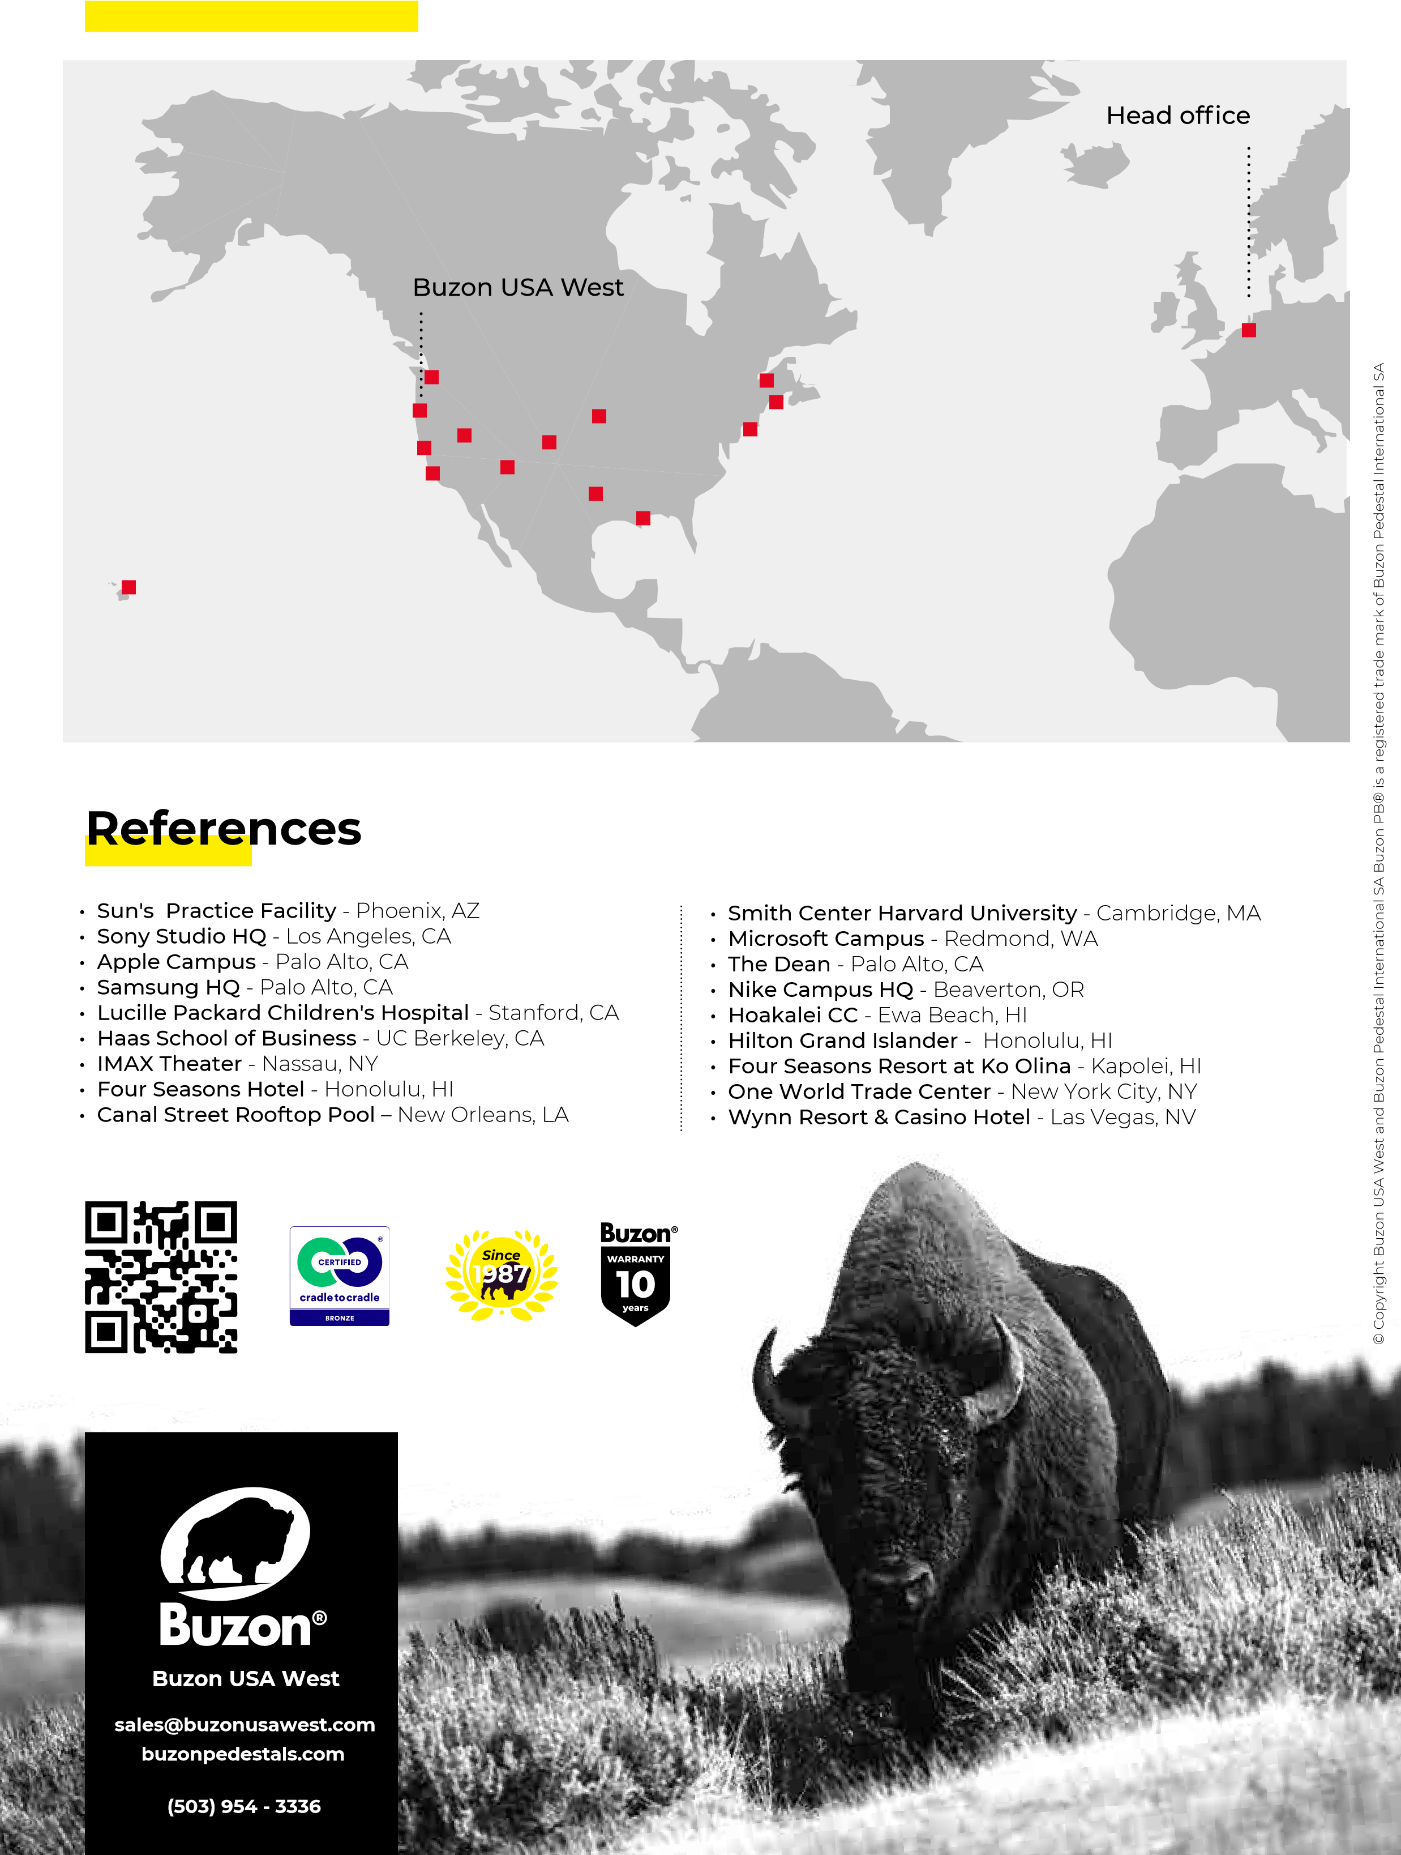
Buzon USA West Projects
_{Buzon USA West Projects}

