Buzon Distributed by ZeroDocs.com

This section includes editing notes to assist the user in editing the section to suit project requirements. These notes are included as hidden text, and can be revealed or hidden by the following method in Microsoft Word:

Display the FILE tab on the ribbon, click OPTIONS, then DISPLAY. Select of deselect HIDDEN TEXT.

SECTION 06 15 36 – PEDESTAL SUPPORTED WOOD DECKING

- GENERAL

  - SUBMITTALS

    - Action Submittals:
      - Shop Drawings: Illustrate products, installation, and relationship to adjacent construction.
      - Product Data: Manufacturer’s descriptive data and product attributes.
      - Samples: [Selection samples.] [Verification samples.]

  - QUALITY ASSURANCE

    - Manufacturer Qualifications: Firm specializing in manufacture of paver pedestal systems, with minimum [15] [__] years’ experience.

    - Installer Qualifications: Firm specializing in work of this Section, with minimum [2] [__] years’ experience.

    - Mockup: Minimum [4 x 4] [__ x __] feet. Approved mockup [may] [may not] remain as part of the Work.

  - WARRANTIES

    - Manufacturer’s 10 year warranty for pedestals and pedestal accessories against manufacturing defective.

- PRODUCTS

  - MANUFACTURERS

    - Pedestal system is based on products by Buzon Pedestals. http://www.buzonpedestals.com/
- US Contact: Buzon USA West
- Sales: 503-954-3336, sales@buzonusawest.com

    - Substitutions: [Refer to Division 01.] [Not permitted.]

  - MATERIALS

    - Wood Decking:
      - Source: [____]
      - Size: Nominally [2 x 6] [__ x __] inches.
      - Species: [Ipe.] [Cumaru.] [Black Locust.] [Kebony.] [Tigerwood.] [____.]
      - Color: [Natural.] [____.] [To be selected from manufacturer's full color range.]
      - Surface texture: [Smooth.] [____.]
      - Finish: [Stained and sealed.] [Unfinished.]

**** OR ****

    - Thermally Modified Wood Decking:
      - Source: [Thermory - North American White Ash.] [Thermally Modified White Ash.] [Thermory - North American Red Oak.] [Thermally Modified North American Black Locust.] by [_________________] [or approved substitute.]
      - Size: Nominal [5/4 x 6 Max] [5/4 x 6 Standard] [1x6 Max] [1x6 Standard] [5/4x4] [1x4] [__ x __] inches.
      - Surface texture: [Smooth.] [____.]

**** OR ****

    - Composite Decking:
      - Source: [Resysta.] [Exterior Bamboo.] [____] by [_______________] [or approved substitute.]
      - Size: Nominal [5/4 x 6] [1 x 6] [__ x __] inches.
      - Color: [____.] [To be selected from manufacturer's full color range.]
      - Surface texture: [Smooth.] [____.]

    - Wood Joists:
      - Grading rules: [NELMA.] [NLGA.] [RIS.] [SPIB.] [WCLIB.] [WRCLA.] [WWPA.] [____.]
      - Species: [____.]
      - Grade: [____.]
      - Surfacing: Surfaced four sides S4S
      - Maximum moisture content: [19] [__] percent.
      - Preservative treatment: Treat lumber in accordance with AWPA U1, Category UC3B - Above Ground/Exposed, Treatment Type [MCA - Micronized Copper Azole.] [DOT - Disodium Octaborate Tetrahydrate.] [___ - ____.]

**** OR ****
    - Aluminum Joists:
      - Source: [Aluminum Joists] [____] by [______________.]
      - Grading: Marine-Grade
      - Size: Actual [1 9/16 x 2 3/16] [__ x __] inches.
      - Color: [Mill - Silver.] [Black.]
      - Surface texture: [Smooth.] [____.]
      - Accessories: End-Connectors, Cross-Bracing Brackets and Screws, Hidden Clips and Screws (for board-decking or for plank pavers)

2.3 ACCESSORIES

- Decking Pedestals:
  - Product: Buzon BC-Series.
  - Description: 80 percent polypropylene and 20 percent talc content, ultraviolet stabilized, weather, sea salt, and chemical resistant.
  - Maximum load capacity: 2,200 lbs (997 kg) per pedestal (to failure); 1,000 lbs per pedestal after safety factor.
  - Self-Ignition Temperature: Provide plastic pedestal with self-ignition temperature greater than 650 degrees F (343 degrees C) in accordance with ASTM D1929 test method.
  - Recycled content: 80 percent.
  - Height: Adjustable from 1/8 inch to 44 inches.
  - Slope: Adjustable from 0 to 15 percent.
  - Provide spacers and correctors to achieve heights and dimensions indicated on Drawings.
  - Maintain pedestal bodies in vertical position (plumb) and heads level by means of bottom-mounted slope correctors.
  - Produce sloped walking surfaces and ramps by means of top-mounted slope correctors.
  - Joist holders: Fixed or Adjustable, to align and mechanically-fastening pressure-treated wood or Aluminum Joists

**** OR ****

- Decking Pedestals:
  - Product: Buzon PB-Series.
  - Description: 80 percent polypropylene and 20 percent talc content, ultraviolet stabilized, weather, sea salt, and chemical resistant.
  - Maximum load capacity: 1,910 lbs (866 kg) per pedestal (to failure); 900 lbs per pedestal after safety factor.
  - Self-Ignition Temperature: Provide plastic pedestal with self-ignition temperature greater than 650 degrees F (343 degrees C) in accordance with ASTM D1929 test method.
  - Recycled content: 80 percent.
  - Height: Adjustable from 1/8 inch to 44 inches.
  - Slope: Adjustable from 0 to 15 percent.
  - Provide spacers and correctors to achieve heights and dimensions indicated on Drawings.
  - Maintain pedestal bodies in vertical position (plumb) and heads level by means of bottom-mounted slope correctors.
  - Produce sloped walking surfaces and ramps by means of top-mounted slope correctors.
  - Joist holders: Fixed, to align and mechanically-fasten pressure-treated wood or Aluminum Joists

  - EXECUTION

  - INSTALLATION

    - Install in accordance with manufacturer's instructions and approved Shop Drawings.
      - Substrate bearing surface on which pedestals are set (such as rigid insulation) shall provide equivalent or greater than 60 psi (414 kPa) compressive strength material when supporting pedestal-pavers or decking.

    - Support each joist per manufacturer’s recommendations.

    - Cut decking or planks to fit at perimeter and around penetrations without voids, or use pedestal-system perimeter spacer-tabs.

    - Allowable Tolerances:
      - Maximum variation from [level] [or] [indicated slopes] of paver surface: Plus or minus [1/4] [__] inch in 10 feet.

END OF SECTION

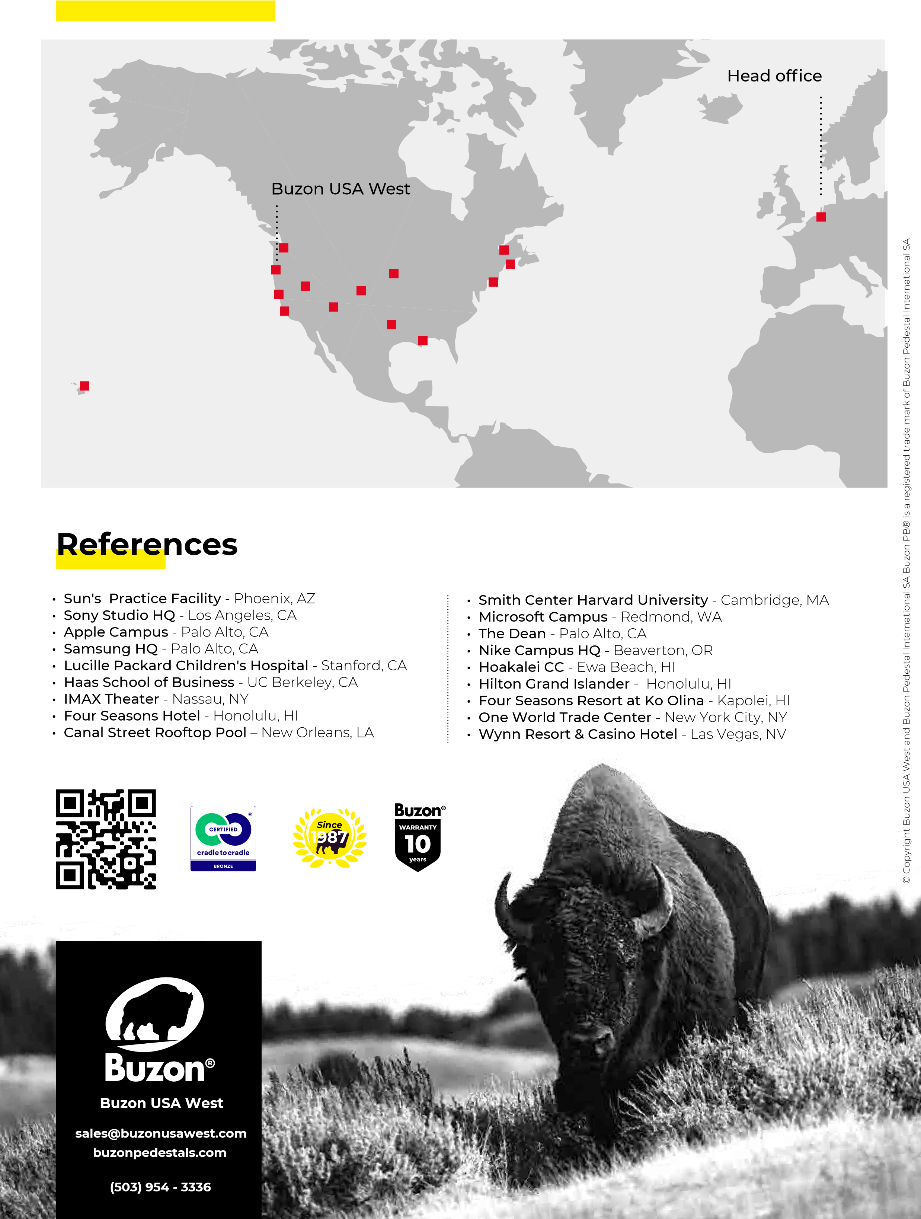
Buzon USA West Projects

